**ECE374 Assignment 4**

Due 03/06/2023

**Group & netid**

*Chen Si chensi3*

*Jie Wang jiew5*

*Shitian Yang sy39*

**Problem 2**

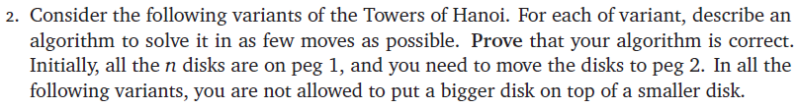

(a) Solution:

Assume the basic MOVE function is defined as *MOVE (from, to)*, which moves the top one disk from peg “*from*” to peg “*to*”.

HANOI_1 (n):

hanoi_1_helper (n, 1, 0, 2)

hanoi_1_helper (n, from, via, to):

if (n=1):

MOVE (from, via)

MOVE (via, to)

else if (n>1):

hanoi_1_helper (n-1, from, via, to) # (ABC, _, _)🡪(C, _, AB)

MOVE (from, via) # (C, _, AB)🡪(_, C, AB)

hanoi_1_helper (n-1, to, via, from) # (_, C, AB)🡪(AB, C, _)

MOVE (via, to) # (AB, C, _)🡪(AB, _, C)

hanoi_1_helper (n-1, from, via, to) # (AB, _, C)🡪(_, _, ABC)

Therefore, we have the running time as T(n) = 3*T(n-1) + 2, with T(1) = 2

So, the steps of dealing with n disks is .

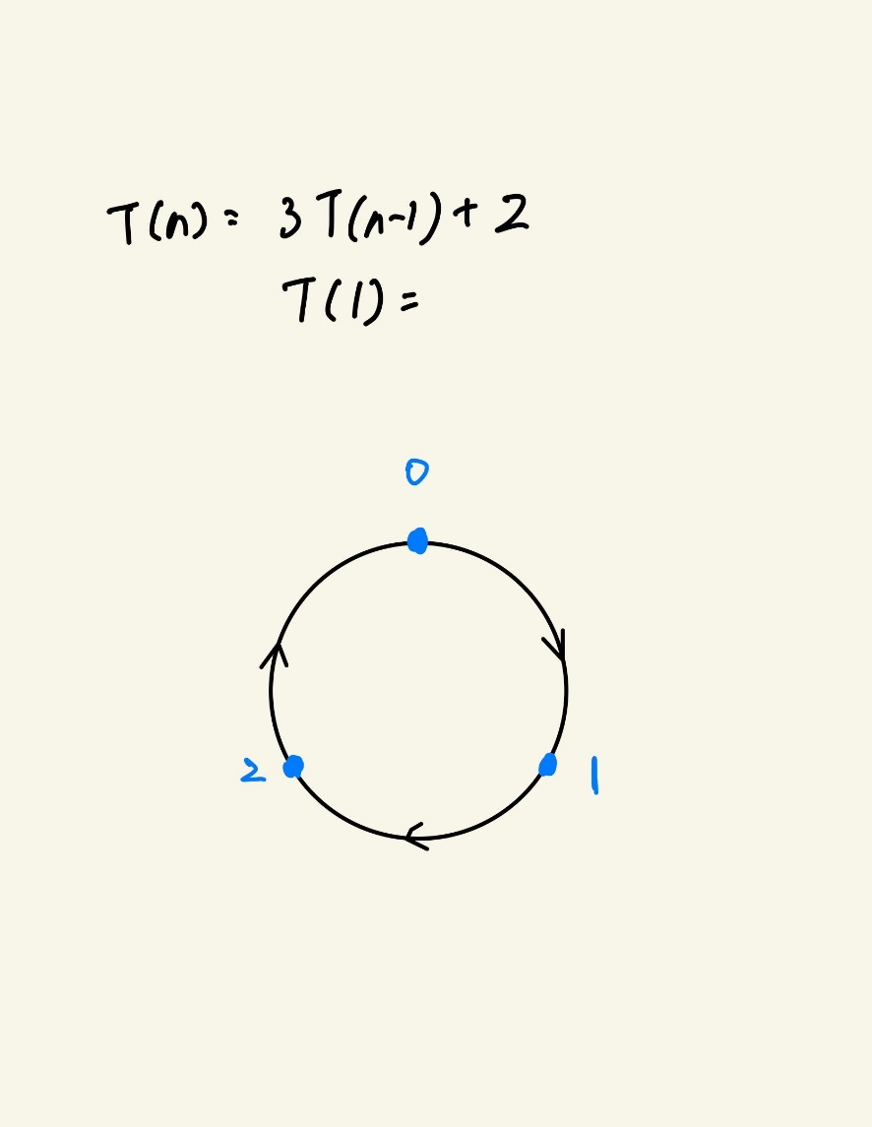(b) 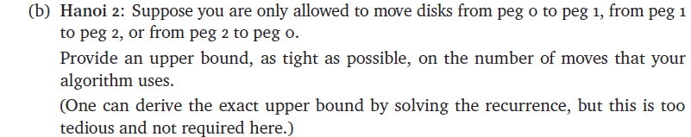Solution:

Intuition:

Consider the setup of these three pegs as left image.

Let Q(n) be the min number of steps to move n disks to the next peg, T(n) be the min number of steps to move n disks to the second next peg.

We have:

(1) Q(n)

To move n pegs to the next peg (e.g. 0🡪1), we need to:

(a) Move n-1 disks from 0 to 2 🡪 T(n-1);

(b) Move the largest disk from 0 to 1 🡪 1;

(c) Move n-1 disks from 2 to 1 🡪 T(n-1)

Therefore, Q(n)=2T(n-1)+1

(2) T(n)

To move n pegs to the second next peg (e.g. 0🡪2), we need to:

(a) Move n-1 disks from 0 to 2 🡪 T(n-1);

(b) Move the largest disk from 0 to 1 🡪 1;

(c) Move n-1 disks from 2 to 0 🡪 Q(n-1);

(d) Move the largest disk from 1 to 2 🡪 1;

(e) Move n-1 disks from 0 to 2 🡪 T(n-1);

Therefore, T(n)=T(n-1)+1+Q(n-1)+1+T(n-1)=2T(n-1)+Q(n-1)+2

Thus, the algorithm is

HANOI_3 (n):

T (n, 1, 0, 2)

Q (n, from, via, to):

if (n=1):

MOVE (from, to)

else:

T (n-1, from, to, via)

MOVE (from, to)

T (n-1, via, from, to)

T (n, from, via, to):

if (n=1):

MOVE (from, via)

MOVE (via, to)

else:

T (n-1, from, via, to)

MOVE (from, via)

Q (n-1, to, via, from)

MOVE (via, to)

T (n-1, from, via, to)

The run-time could be obtained by solving the equation:

Solving it, and we get , , and therefore

(c) 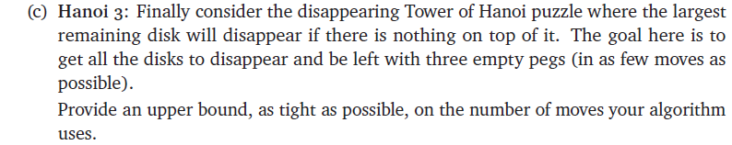Solution:

Intuition:

HANOI_3 (n):

from = 1

via = 0

to = 2

while (n > 2):

hanoi_3_helper (n-2, from, via, to) # (ABCDEF, _, _)🡪(EF, _, ABCD)

MOVE (from, via) # (EF, _, ABCD)🡪(F, E, ABCD)

DISAPPEAR (from) # (F, E, ABCD)🡪 (_, E, ABCD)

DISAPPEAR (via) # (_, E, ABCD)🡪 (_, _, ABCD)

n = n – 2

SWAP (from, via)

if (n = 2):

MOVE (from, via) # (AB, _, _)🡪 (A, B, _)

DISAPPEAR (from)

DISAPPEAR (via)

# if n=1, it would directly disappear

if (n=1):

DISAPPEAR (from)

# Traditional Hanoi Tower Movement

hanoi_3_helper (n, from, via, to):

if (n=1):

MOVE (from, to)

else if (n>1):

hanoi_3_helper (n-1, from, to, via) # (ABC, _, _)🡪(C, AB, _)

MOVE (from, to) # (C, AB, _)🡪(_, AB, C)

hanoi_3_helper (n-1, via, from, to) # (_, AB, C)🡪(_, _, ABC)

The time complexity of this algorithm is:

, T(0)=0

Therefore, the time complexity of this algorithm has an upper bound of .